Grade correction for Miss Claudia Go Viguer
The course 2190250 Computer Architecture and Organization (2022/2)

The score of Miss Viguer originally submitted to the faculty is as follows: (and her grade is C+)
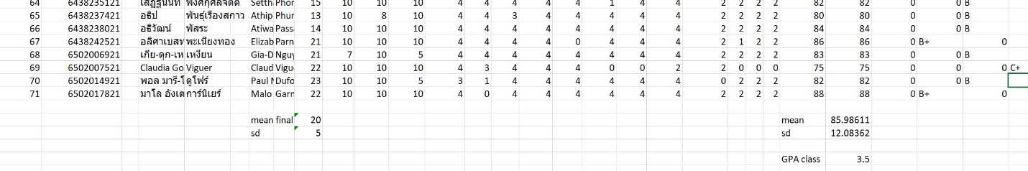
<fig of raw original score>

Her original total score (out of 100) is 75.
Here is the grading rule I announced (in Mycourseville)
==============================
Total score = final (30) + midterm (30) + homework (32) + in class (8) = 100
Your final exam is average 19.97, SD 5.0. I am happy.
Your total score is average 85.98, SD 12.08. Good performance
Here is how to calculate grading. I peg the average at B+. So, here we go:
>= 90 A
>= 85 B+
>= 80 B
else C+
Your class GPA is 3.51, congratulation !
==============================================
Miss Viguer came to attend the class about a month late. So, she missed out the submission of the first three homework and in-class. She asked me for late-submission and I agreed.
However, the original grade that I submitted to the faculty did not include these scores of Miss Viguer's first month homework and in-class. As I did not find that in Mycourseville system while I did the grading.

Miss Viguer sent her work to me via Discord which I used to communicate with all students in the class. I found that file and I update her score.
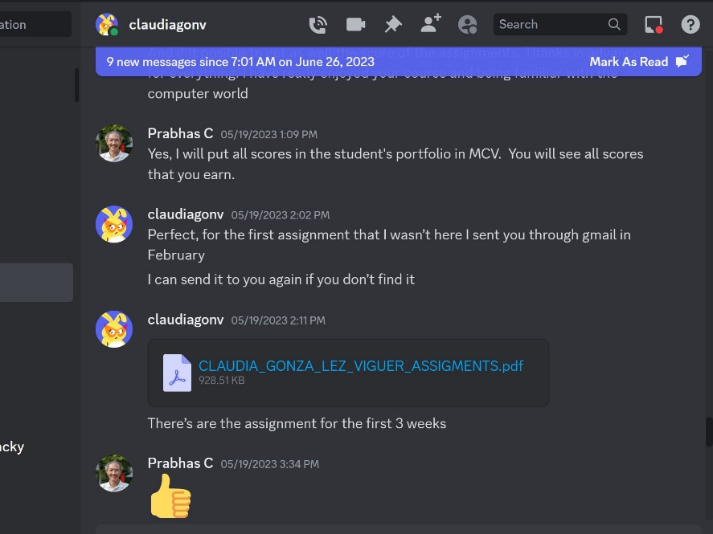
<figure corresspondence>

Then, the result is that her total score becomes 81 and her grade is "B".
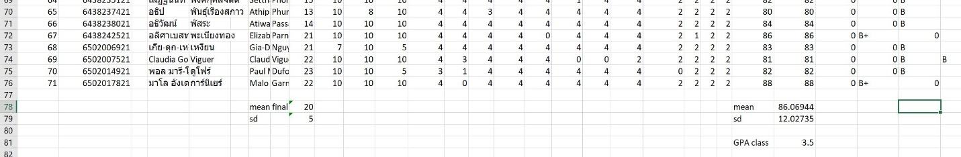
<figure of update score>

So, I want to change her original grade from "C+" to the corrected one "B".

I include the first row of my score sheet to show the label of each work.
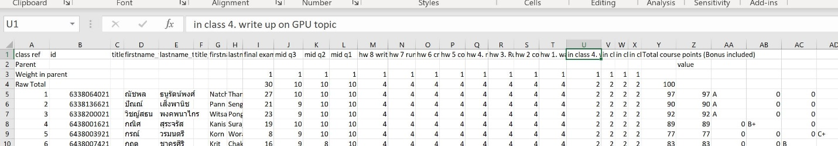
<figure lable score>

The reason of so late change.

I have too many documents to track for this class. There are Midterm, Final, Homework, Inclass (totally 16 pieces of work per a student). I did manage by having all students submit their work in Mycourseville. When I found out that Miss Viguer work is out-of-sync, I could not find the file she submitted to me. It took a lot of time and effort to get it.

I apologise for this late correction.

Prabhas Chongstitvatana
30 August 2023

