Emergent Environments Parameter Adjustment in Games and Nature Simulations Using Neural Networks

Tanawat Kumnoonsate and Vishnu Kotrajaras
Department of Computer Engineering, Chulalongkorn University
Patumwan, Bangkok 10330, Thailand

Email: g49tkm@cp.eng.chula.ac.th and vishnu@cp.eng.chula.ac.th

Abstract

This paper discusses the design, implementation, testing and application of neural networks for controlling behaviors of cellular automata-based maps by adjusting maps' properties. We also implement a map editing tool that can create scenarios in emergent environment maps automatically using technique discussed in this paper. By using this tool, game developers and ecological modelers are able to create scenarios in this type of map with less time and effort. Examples of features in commercial games that can be improved by using emergent environments are also provided.

Key Words: Neural Networks, Cellular Automata, Emergent Environments

1. Introduction
For computer games that rely on players interacting with the game maps, or ecological simulations that model natural disasters, emergent and realistic environments become crucial to their degree of realism. Emergent environments can be created on a map by dividing the map into cells, augmenting the cells with various physical properties, and building rules for influencing properties between each cell [1]. Natural phenomena, such as fire, look more dynamic and realistic than similar phenomena created using scripts [2].
For computer games, emergent maps have not seen much use. One reason is because when a given scenario is required to take place on a map, every property of every cell needs to be set in order to produce such scenario. Developers need to put in a lot of time and effort. Moreover, scenarios that have not been well-set may behave in ways that the developers had not anticipated. One way to produce the desired scenario is to make properties inactive and play out the scenario using a script, and then switch the properties back on later. This solution has a limitation, because players cannot interfere with the scenario. Players must wait until the scenario is completely finished before being able to do anything to any altered part of the map.
Cellular automata maps have been widely used in ecological modeling [3]. However, their usage is in the form of "Setting all properties first (usually imitating an actual natural map) then let the scenario plays itself out". The study of what causes a given scenario is through trial and error. It will be very useful if, given a scenario, natural properties that cause it can be found automatically.
We present in this paper an application of neural networks for adjusting properties of every cell on a cellular automata map in order to produce a given scenario. With tool based on our technique, game developers and ecological modelers are able to focus on designing their scenario and spend much less time setting cell properties.

2. Related Works
Regarding game environment, Sweetser has developed and tested a deterministic cellular automata-based map [1] for Real-Time Strategy games. Sweetser’s experimental system was called EmerGEnT system. Although EmerGEnT system did not model an environment in great detail, it was good enough for using in games, with fire, water, and explosions being integrated into its cellular automata properties. We modeled our own emergent environment after it. However, in our experiment, we modeled only fire with simpler equations in order to experiment with neural networks. Our current environment can be divided into 3 levels, similar to EmerGEnT system. The first layer is "behavior" – the effects that players see. The second layer is "rule" – control behavior both between cells and within each cell. Finally, "property" is our final layer – determining factors of how cells interact according to the rules. Sweetser’s work, although consists of more physical properties, does not provide any feature for setting cell properties following given effects that users see.
A probabilistic model can also be used to simulate fire in broad-scale over long time periods [3]. Hargrove’s model was designed for simulating real forest fires. It included humidity, fuel types, wind, and firebrand. These factors influenced probability of fire spreading from one cell to another, and probability of isolated cells getting ignited. Our work currently includes only humidity and fuel types. However, the uses of these two parameters are very different from Hargrove’s. While the humidity value in each of Hargrove’s cells is only used for determining the spread probability and remains constant during simulation. Our cell humidity values change according to surrounding fire. Another difference is that an ignited cell in Hargrove’s model will stop burning in one unit of time, while an ignited cell in our model can continue to burn according to the amount of fuel left in it. Fuel types in Hargrove’s model are only used for determining probability. Most importantly, Hargrove’s model and other ecological simulators still do not provide any feature for setting cell properties automatically following given scenarios.
Probabilistic models do not perform well for small cell sizes compared to thermodynamic models (Hargrove et al. used 50 x 50 m² cell size in their work.). To be able to work with cells in a game map, which generally represents small areas; thermodynamic models are more suitable. Probabilistic models are also more difficult to control compared to thermodynamic models, which have precise rules for events.
Techniques for adjusting environment properties include searching algorithms such as hill climbing and neural networks. Hill climbing can be used for tuning system parameters. Merz et al. [4] developed Opi-MAX for tuning MAX's numeric parameters. MAX is an expert system for high-level diagnosis of customer-reported telephone troubles. It can be customized by changing a set of numeric parameters. Opi-MAX uses a searching algorithm called greedy hill-climbing to optimize parameters. It works by randomly changing parameters one by one. A parameter is repeatedly changed from its initial value and each of its change effect can be observed from overall output. A change that results in a better output will be carried out, and a change that does not contribute to a better output will be ignored. Each parameter is changed for a constant number of times. The system stops when all parameters are dealt with. This technique, however, may not be suitable for our work, since we have no good initial values of any property. Moreover, maps that we use can have hundreds or thousands of parameters in total, making linear search algorithms, such as Opi-MAX’s algorithm, unusable.
Neural networks can also be used for parameter tuning. Legenstein et al. [5] developed a movement prediction method for objects moving on 8 x 8 grids. Each cell on a grid provides an input to the recurrent unsupervised neural networks. It can predict object movement by predicting sensor inputs, which are numeric values like cell properties. Their neural networks were trained online while our own neural networks were trained offline. Given previous events, Legenstein et al.’s work predicts the next event, while our work predicts the initial condition given a sequence of events in time.

3. Designing and Setting up the Emergent Environment
Our work was built upon deterministic cellular automata-based maps. A neural network was associated with each cell of each map. Each neural network was trained to set the property of each environment cell based on cellular automata transition rules and the desired behavior of neighboring cells and itself.
Our prototype maps consisted of neural networks that control the spreading of fire on the maps. The environment that simulates fire on grass fields based on humidity and fuel (the intensity of the grass) was constructed. Each grass cell was a cellular automaton with two states - burning and not burning (Outside of the grass fields, we assume that the status is always not burning.).
Humidity of grass varied from 0 - 9 unit. The amount of fuel in each cell was fixed at 9 units. The rules of fire used are:
- In one unit of time, humidity of each cell is reduced by an amount equal to the number of neighboring burning cells.
- A cell is "burning" if its humidity is less than or equal to zero and there is fuel left in the cell.
- In one unit of time, a burning cell has its fuel reduced by an amount equal to the number of neighboring burning cells plus one.
Each cell’s neural network was constructed using three-layer perceptrons. The neural network on a map cell had 9 inputs. The first input was "burning time" – the duration that the cell had been on fire. Each of the remaining eight inputs was "burning delay" – the time the cell took to catch fire after one of its eight neighboring cells caught fire. (The value of -1 was used if the neighboring cell had not caught fire before the current cell.) The output of the cell’s neural network contained all properties of the cell.

Possible input/output values of our neural network can be seen in figure 1. The values are shown below the name of each input and output block. The number of neurons in each layer is shown at the center of each layer’s block.

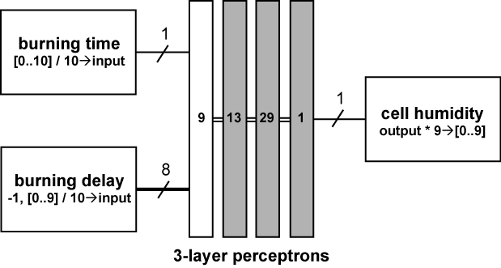
Figure 1. Diagram of neural network and it’s input/output used in the prototype environment.

Training of the neural networks was done automatically. First, a map was generated, with each cell containing random properties. Then, events were randomly generated at several locations on the map (For instance, a fire was started on a cell.). The spreading of fire in that situation was used as training data for the neural networks. Properties of cells were used as expected output. The training was then repeated. In our prototype, we trained neural networks until mean square error became less than 10⁻³ (about 30000 rounds) using 1000 random data sets. Each simulation lasts 10 time units (frames).

4. Results
Testing was initiated in a map with 100 x 100 cells by randomly setting cells' humidity and having cells with humidity value of 0 acting as the initial fire positions (so about 10% of the map became the initial fire positions). Then, the spreading of fire was observed for 10 frames. Since most of the cells would be completely burnt by the 10th frame, we only needed to observe 10 frames. The neural networks received the fire behavior as their input and then adjusted the humidity of the cells and played out the spreading of fire after the adjustment. Then, we compared burning behavior and humidity obtained from the neural networks with the original. Testing with 100 test scenarios, the average percentage of cells that did not burn with exact timing as the original, compared frame by frame, was 7.81%. More complex topology of neural network may reduce this error. We considered this result as acceptable considering the large number of actual cells needed to be set. The difference between expected scenarios and the scenarios created by the neural networks was almost visually unnoticeable.

Figure 3. Burning error / map size graph

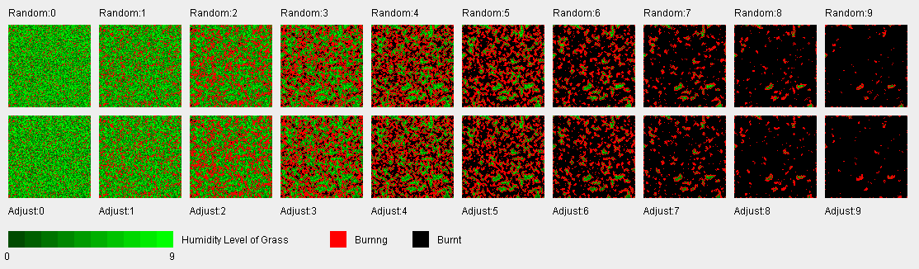
In term of cells humidity property, 59.61% of the cells did not receive their original humidity values. This number seems large. However, when examined closely, most of the errors were only one unit apart from their original values. Only one third (20.99%) of the cells with property errors had greater than one unit error, and only one ninth (6.61%) had error greater than two units. For applications in games, what we are most concerned is the observable burning behavior, not the properties. Therefore this error is irrelevant. For nature simulations, more accurate models may be needed if the domain of use requires very precise predictions for even small areas. But for most nature simulations, our result should be adequate.
Figure 2. Target map (top), compared frame by frame, against neural networks adjusted map (bottom)
We also carried out the same tests for other map sizes varying from 10 x 10 cells to 200 x 200 cells. Both burning errors and humidity errors seemed to be higher in smaller maps and decreased exponentially as map size grew – 12.43% burning error and 64.44% humidity error in 10 x 10 maps compared to 7.56% burning error and 59.38% humidity error in 200 x 200 maps.

Figure 4. Humidity error / map size graph

5. Map Editing Tool
In order to make use of our technique, we developed a tool which combines map editor and the neural networks. With this tool, cellular automata map users can create any scenario on maps straight away.

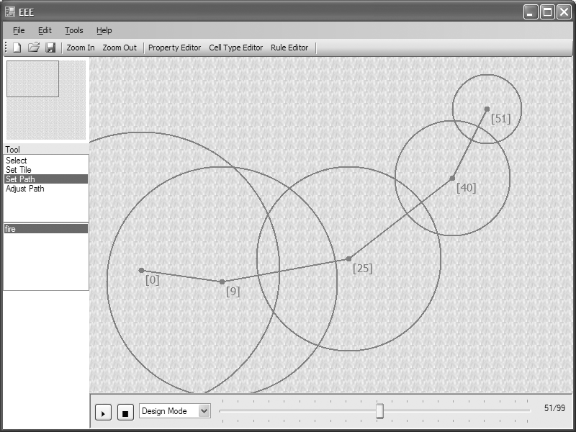
Figure 5. Emergent Environment Editor – showing a path with 5 nodes
Our neural networks map editor is called "Emergent Environment Editor". It has more components than typical map editors, as follows:
Cell’s property editor – set each cell properties manually.
Property editor – set available types of property, such as fuel and humidity, in a map.
Cell type editor – set available types of cell in a map. Each cell type has its own possible range of properties. For example, it is impossible for a grass cell to contain more fuel than a tree cell. Therefore the amount of fuel in a grass cell can be constrained from 1-3, while the amount of fuel in a tree cell can be constrained from 4-6.

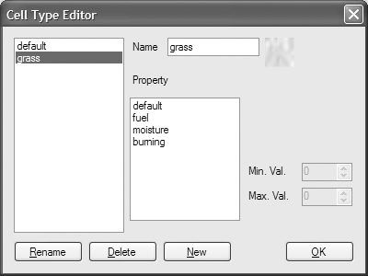
Figure 6. Cell Type Editor

Rule editor – set rules to control the behavior of a phenomenon in the map. Each rule is a combination of expressions. Users can setup rules freely, not limited to rules about fire. Rules are linked to one of the available properties. For example, burn property can be set to show the effect of our rule about fire.
Neural networks – are the core of the automatic cell properties adjustment system. There are separate neural networks for each rule and cell type. All of them are trained by the method described earlier. More than one phenomenon may occur in the same cell which leads to many possibilities of neural networks outputs for the same property. However, different phenomena do not usually affect the same property. Consequently, to set a cell property, our tool will only use output from the neural networks of the phenomena related to that property. If there is more than one possible value for the property, an average is taken.
Path editor – set path of a spreading incident such as the spreading of fire. Each path is a list of nodes describing location, radius and timing of a desired effect. All paths will be converted to the table of the beginning and ending time of a desired incident for each cell. The neural networks use this table as input for adjusting cells' properties.
Effect player – display the effect of a desired scenario using the table of the beginning and ending time of a desired incident (Design Mode), or using cellular automata (Automata Mode). Maximum time that the desired effect can be presented is limited to 100 frames, which is equal to 100 seconds, as specified by the tool.

All graphics in the tool are 2D. However, graphics in games of which maps are created by this tool are not limited to 2D. Also, each time unit in games does not need to be one second.

6. Contribution
In some commercial games, players can have interaction with game environment. For example, in Command & Conquer: Generals (2003), players can set up fires on a map, and the fire can damage opponent units. But these fires are static. In Bahamut Lagoon (1996), players can use terrain to take advantage of enemies. For example, players can set fire to forests to damage enemies.
Some games have natural phenomena which affect gameplay, such as Star Wars: Empire at War (2006), where each planet has different weather, which can slow down units, reduce units’ line of sight, etc.
These games can be made more realistic by implementing emergent environment. But with emergent environment, game behaviors are hard to control. This is where our tool and technique can come in. Controllable games scenarios lead to the following features, which are usually unavailable in emergent games:
- Editable Scenario – Scenario is very important for games. Crucial moments in a game story can be revealed using well-set scenarios. Furthermore, a well-set scenario can provide challenge for players. Normally, a scenario is played out using scripts, sacrificing any possible interactions from players. Our editable scenario is different. Developers can specify how a scene is played out just like writing scripts to dictate what happens during the game, but the environment remains emergent throughout the entire play.
- In-game Cut-scene – Although cut-scenes produced as movies can be used, in-game cut- scenes can tell story while players are still in the middle of scenarios, without disrupting game flow.
With accurate physics rule, this work also has potential for being an analyzer for natural phenomena. For example, number of trees that needs to be cut down in order to maintain certain natural fire boundaries in a national park can be estimated. Also, given burning scenarios, the number of starting vegetation in the forest can be determined.

7. Conclusion and Future Work
From our experiment, we conclude that neural networks can be used effectively for tuning parameters in emergent maps for games and ecological simulations.
There is much work to be done, however. Our neural networks are only tested with the spreading of fire through adjacent cells and only able to set initial property values for cell humidity. In order to model and control a more realistic fire, additional properties such as wind and firebrand need to be implemented. Water and pressure are also interesting additions. We plan to integrate such natural phenomena into our next version of the tool. With more complex scenarios, neural networks topology may also need change in order to remain effective. We plan to use neuroevolution technique to obtain more suitable topology. Also, in our current system, phenomena duration is limited to 100 frames. Larger time frame is required for more detailed scenarios. It is also important that more functions need to be added to our tool in order to match existing map editing tools.

8. References
- Sweetser, P. and Wiles, J. 2005. "Using Cellular Automata to Facilitate Emergence in Game Environments." In Proceedings of the 4th International Conference on Entertainment Computing (Sanda, Japan Sep. 19-21).
- Sweetser, P. and Wiles, J. 2005. "Scripting versus Emergence Issues for Game Developers and Players in Game Environment Design." International Journal of Intelligent Games and Simulations 4 (1): 1-9.
- Hargrove, W.W. et al. 2000. "Simulating fire patterns in heterogeneous landscapes" Ecological Modelling 135(2-3): 243–263.
- Merz, C.J. et al. 1996 "Tuning Numeric Parameters of a Knowledge-Based System for Troubleshooting the Local Loop of the Telephone Network." IEEE Expert, Feb.: 44-49.
- Legenstein, R.A. et al. 2003. "Input Prediction and Autonomous Movement Analysis in Recurrent Circuits of Spiking Neurons." Neurosciences (Special Issue on Neuroinformatics of Neural and Artificial Computation), 14(1-2): 5-19.

