Chapter 4: More on Data Types

Objectives
Students should
- Understand how to work with different data types including calculations and conversions.
- Be aware of imprecision in floating point calculations.
- Understand overflow, underflow, Infinity, NaN, and divided-by-zero exception.
- Understand and be able to use increment and decrement operators correctly.
- Be able to use compound assignments correctly.

Numeric Data Type Specification
If we type numbers without decimal points, such as 1, 0, -8, 99345 etc., the data types of those numbers are all int by default. If we type numbers with decimal points, such as 1.0, 0.9, -8.753, 99345.0 etc., the data types are all double by default.
At times, we may want to specify a specific data type, apart from the two default types (int and double), to some numeric values. This can be done by:
- adding an l or an L behind an integer to make its type long.
- adding an f or an F behind a floating point value to make its type float.
- adding a d or a D behind a floating point value to make its type double.
Note that for the type double, adding a d or a D is optional, since double is the default type for a floating point value.
All of the following statements assign data to variables whose types are similar to the type of the data.
int i = 1;
long l = 1L;
long k = 256l;
float f = 2.0f;
float g = -0.56F;
double d1 = 1.0;
double d2 = 2.0D;
double d3 = 2.0d;

Data Type Conversion
As mentioned earlier, data can be assigned to only variables whose types are the same as the data. Failure to do so generally results in a compilation error. However, in some situations we need to assign data to variables of different types. Therefore, data type conversion is needed.
Data type conversion can be done explicitly by using cast operators, written as the name of the data type, to which you want to convert your data to, enclosed in parentheses. Cast operators are put in front of the data to be converted. Cast operators have higher precedence than binary arithmetic operators but lower precedence than parentheses and unary operators. That means type conversion by a cast operator is done before +,-,*,\, and %, but after () and unary operators.
Converting floating point numbers to integers will cause the program to discard all of the floating points, no matter how large they are.
See the two examples shown below.
public class TypeConversionDemo1 1
{ 2
public static void main(String[] args) 3
{ 4
int i; 5
double d = 0.0; 6
i = (int) d; 7
System.out.println("d ="+d); 8
System.out.println("i ="+i); 9
i = 9; 10
d = (double) i; 11
System.out.println("d ="+d); 12
System.out.println("i ="+i); 13
} 14
} 15

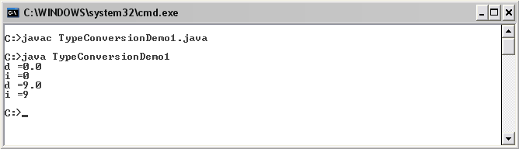
The cast operator (int) is used on line 7 for converting the double value 0.0 stored in the variable d to the type int. Then it is assigned to the variable i which is of type int. The cast operator (double) was used on line 11 for converting the int value 9 stored in the variable i to 9.0. Then, it is assigned to the variable d which is of type double.
public class TypeConversionDemo2 1
{ 2
public static void main(String[] args) 3
{ 4
int i,j; 5
double d1 = 0.5, d2 = 0.5, d3,d4; 6
i = (int)d1+(int)8.735f; 7
j = (int)(d1+d2); 8
System.out.println("i = "+i); 9
System.out.println("j = "+j); 10
d3 = (double)i-(double)j; 11
d4 = (double)(i-j); 12
System.out.println("d3= "+d3); 13
System.out.println("d4= "+d4); 14
} 15
} 16
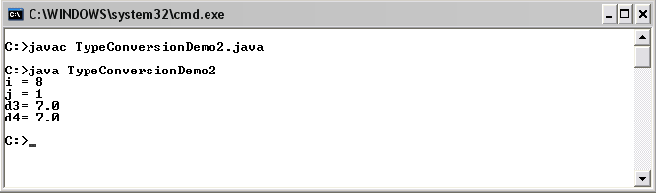
On line 7, d1 whose value is a double 0.5 is converted to int using the (int) operator. The resulting int value is 0 since decimal points are truncated. On the same line, the float value of 8.735f is also converted to the int value of 8. So, i equals 0+8 = 8. On line 8, the sum of d1 and d2 is a double 1.0. It has to be converted to an int 1 using the (int) operator. On line 11, the int values in i and j are converted to double using the (double) operator before being subtracted and assigned to the variable d3, which is of type double. On line 12, the two double values in i and j are operated first before the resulting int value is converted to double.
Explicit casting must be used (i.e. cast operators must be used) when converting wider data types (i.e. data types with larger numbers of bytes) to narrower data types (i.e. data types with smaller numbers of bytes). However, converting narrower data types to wider data types can be done implicitly without using cast operators. In other words, Java can convert data types automatically if the destination types take up more bytes than the original data types. For example, double d = 2.5f; can be done without any explicit use of a cast operator, while float g = 2.5; will result in a compilation error since the value 2.5 is of type double, whose size is 8 bytes, and it is assigned to a variable of type float, whose size is 4 bytes. To perform such an assignment, float g = (float) 2.5; must be used.
The following table shows the possibility of converting among primitive data types. The label ‘A’ means that the data type on that row can be automatically converted to the data type in that column. The label ‘C’ means that the associated cast operators are required. The label ‘X’ means that such a conversion is not allowed in Java.
from\to | byte | short | int | long | float | double | char | boolean
byte |  | A | A | A | A | A | C | X
short | C |  | A | A | A | A | C | X
int | C | C |  | A | A* | A | C | X
long | C | C | C |  | A* | A* | C | X
float | C | C | C | C |  | A | C | X
double | C | C | C | C | C |  | C | X
char | C | C | A | A | A | A |  | X
boolean | X | X | X | X | X | X | X
* indicates that precision lost might occur from the conversion.
Note that the conversion from a wider data type to a narrower data type is called narrowing, while the opposite is called widening.

Data Types from Expressions
It is not uncommon to run into an expression that contains operators whose operands are values and/or variables of different data types. Consider the statements below.
public class DataTypesFromExp 1
{ 2
public static void main(String[] args) 3
{ 4
int k = 10; 5
System.out.println("k/3 = "+k/3); 6
System.out.println("k/(float)3 = "+k/((float)3)); 7
System.out.println("k/3.0 = "+k/3.0); 8
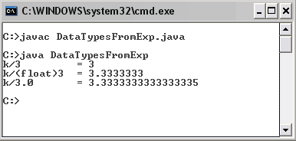
}
}

On line 6, the expression k/3 is an operation between two int values. The result of this expression is a value of type int, as we can see no decimal points in the output. Doing simple division by hand, we can see that 10/3 results in 3.333… However, following some rules which we are going to discuss later, the resulting data type of k/3 must be an int. Thus, 3.333… is truncated to the integer 3. Following the same set of rules, the resulting type of an operation between an int and a float, such as k/((float) 3), is a float and the resulting type of an operation between an int and a double, such as k/3.0, is a double.
Here is the rule that governs the resulting date types of expressions with operands with mixed data types.
Consider A $ B where $ is a binary operator, while A and B are its operands. When A and B are of the same data type, the resulting data type is that data type.
- If either operand is of type double, the other is converted to double.
- Otherwise, if either operand is of type float, the other is converted to float.
- Otherwise, if either operand is of type long, the other is converted to long.
- Otherwise, both operands are converted to type int.
The table below gives us some example statements and their results.
Statement | Value of x | Statement | Value of x
float x = 8/9; | 0.0f | int x = (int)(1.5+1.5) | 3
double x = 10d + 8/9 | 10 | double x = (int)1.5+1.5 | 2.5
double x = (10.0+8)/9 | 2.0 | double x = 3/4.0 | 0.75
float x = 8.0+9; | error | double x = 3/4*4/3 | 0.0
double x = (1/4)*(12d-4) | 0 | double x = 4/3*(float)3/4 | 0.75

Limitation on Floating Point Computation
Consider the source code listed below. First, a variable d is defined and initialized to 0.0. The program adds 0.1 to d ten times. The program shows the current value of d after each time 0.1 is added to d.
public class LimitedPrecision1
{
public static void main(String[] args)
{
double d = 0.0;
double increment = 0.1;
System.out.println("Original d \t\t="+d);
d += increment;
System.out.println("d + 1 increments \t="+d);
d += increment;
System.out.println("d + 2 increments \t="+d);
d += increment;
System.out.println("d + 3 increments \t="+d);
d += increment;
System.out.println("d + 4 increments \t="+d);
d += increment;
System.out.println("d + 5 increments \t="+d);
d += increment;
System.out.println("d + 6 increments \t="+d);
d += increment;
System.out.println("d + 7 increments \t="+d);
d += increment;
System.out.println("d + 8 increments \t="+d);

d += increment;
System.out.println("d + 9 increments \t="+d);
d += increment;
System.out.print("d + 10 increments \t="+d);
}
}

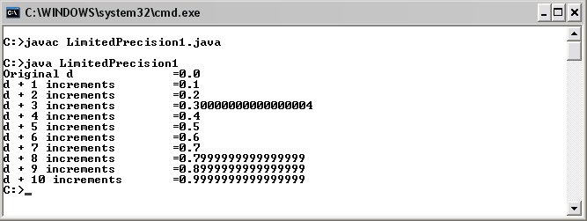

The above figure shows the output of the program. With simple mathematics, one will definitely say that the eventual value of d is 1.0. However, when this program is executed, we have found that the eventual value of d is very close to but not exactly 1.0. This is because of the imprecision of representing floating point values with binary representation. Thus, some decimal points cannot retain their exact decimal values when represented with binary representation. And, 0.1 is one of them.
With this fact kept in mind, one should be aware that floating point values should not be compared directly with relational equality operators (== and !=). A good practice for comparing a floating point value A and a floating point value B is to compute d = |A-B|, and see whether d is small enough. if so, you could consider that A equals to B.

Overflow and Underflow
It is possible that the results of some arithmetic operations are larger or smaller than what numeric values can handle. When a value is larger than the biggest value that a data type can handle, it is said that an overflow has occurred. In contrary, if a value is smaller than the smallest value that a data type can handle, that value might be rounded to 0. This situation is called underflow. Overflow and underflow might cause some arithmetic computations to yield unexpected results.
The program Overflow1.java listed below shows an example of when overflows have occurred. A variable veryBigInteger of type int is declared and set to a big integer value of 2,147,483,647, which is still in the range that int can handle. Adding 1 to 2,147,483,647 would normally result in 2,147,483,648. However, such a value is too large for an int. Thus, the program gives an unexpected answer. A similar situation happens when 1 is subtracted from a very small number -2,147,483,648 and when 2,147,483,647 is multiplied by 2. Notice that the program does not warn or give any errors or exceptions when an overflow occurred with int. Thus, programmer should be aware of this situation and prevent it for happening.
public class Overflow1 1
{ 2
public static void main(String[] args) 3
{ 4
int veryBigInteger = 2147483647; 5
System.out.println("veryBigInteger = "+veryBigInteger); 6
System.out.println("veryBigInteger+1 = "+(veryBigInteger+1)); 7
int verySmallInteger = -2147483648; 8
System.out.println("verySmallInteger = "+verySmallInteger); 9

System.out.println("verySmallInteger-1 = "+(verySmallInteger-1)); 10
System.out.println("veryBigInteger*2 = "+(veryBigInteger*2)); 11
} 12
} 13
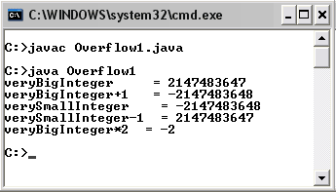

The program Overflow2.java shows an example of when an overflow occurred with double. However, Java has a floating point value (both float and double) that can handle a very large number. Such a value is Infinity. Remember that Infinity is a floating point value. So, it can be treated as one. –Infinity represents a floating point value that is very small. Also, notice the effect of Infinity from the result of line 12.
public class Overflow2 1
{ 2
public static void main(String[] args) 3
{ 4
double d = 1.0e308; 5
double dSquare = d*d; 6
System.out.println("d = "+d); 7
System.out.println("d^2 = "+dSquare); 8
System.out.println("-d^2 = "+(-dSquare)); 9
System.out.println("sqrt(d^2) = "+Math.sqrt(dSquare)); 10
} 11
} 12
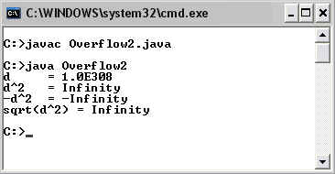

The program Underflow1.java shows an example when a value becomes closer to zero than its associated data type can handle, it is rounded to zero. In this example, d is set to 1.0×10⁻³²³, which is still in the precision range of a double. Divide that value by 10 results in the value that is closer to zero than what double can handle. Consequently, the result of the expression d/10*10 becomes zero since the division is executed first and it results in a zero. Notice the difference between the value of p and g.
public class Underflow1 1
{ 2
public static void main(String[] args) 3
{ 4
double d = 1.0e-323; 5
double p = d/10*10; 6
double g = 10*d/10; 7
System.out.println("d = "+d); 8
System.out.println("d/10*10 = "+p); 9
System.out.println("10*d/10 = "+g); 10
} 11
} 12

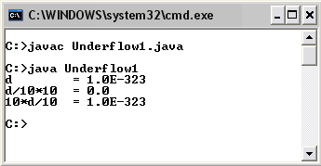

Dividing by Zero
When an integer value is divided by zero, mathematically it will results in an infinite value. In Java, there is no such integer value. Thus, whenever an integer is divided by a zero, the program will give out an exception during the execution of that program and terminate, as shown in DivBy0DemoInt.java below. However, when a floating point value, apart from 0.0, is divided by 0, the resulting value is Infinity. When 0.0 is divided by 0, the resulting value is NaN, which stands for Not a Number. An example with Infinity and NaN value can be seen in DivBy0DemoDouble.java listed below.
public class DivBy0DemoInt
{
public static void main(String[] args)
{
int zero = 0, i = 100;
System.out.println(i/zero);
}
}

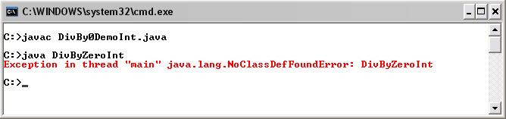
public class DivBy0DemoDouble
{
public static void main(String[] args)
{
double zero = 0, i = 100;
System.out.println("100/0 ="+i/zero);
System.out.println("0/0 ="+(0/zero));
}
}

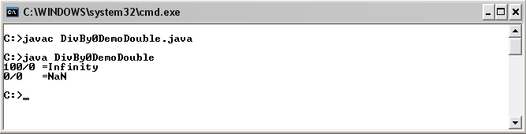

Compound Assignment
One common task found frequently in general computer programming is when an operator is applied to the value of a variable, and then the result of the operation is assigned back to that variable. For example, k = k + 7;, m = m*3;, and s = s+”ful”;. These can be written in a shorthanded fashion in Java.

Let ◊ be a Java operator, k be a variable, and m be any valid Java expression. The operation:
k = k ◊ m; can be written as k ◊= m;

For example,
k = k + 1; can be written as k += 1;
i = i * 8; can be written as i *= 8;
j = j / 3; can be written as j /= 3;
s1 = s1 + s2; can be written as s1 += s2;

Increment and Decrement
Java has special operators for incrementing and decrementing a numeric variable. The increment operator (++) add to the value of the variable to which it is applied. The decrement operator (--) subtract from the value of the variable to which it is applied.
++k and k++ is equivalent to k = k +1; or, similarly, k += 1;
--k and k-- is equivalent to k = k – 1; or, similarly, k -= 1;
The difference between when the increment or decrement operator is applied prior to the variable (prefix version) and after the variable (postfix version) becomes apparent when it is a part of a longer expression when the value of the variable is used. In such a situation, if an increment or decrement operator is applied prior to the variable, the value of that variable increases or decreases by one prior to being used as a part of the expression. In contrary, if it is applied after the variable, its value is used prior to the incrementing or the decrementing.
Consider the following code segment.
int k = 1; 1
System.out.println(++k); 2
System.out.println(k); 3

The statement on line 2 causes k to increase to 2 first and then it is printed out later. Therefore, the statement on line 3 prints the current value of k which is also 2 on screen.
Now consider a rather similar code segment.
int k = 1; 1
System.out.println(k++); 2
System.out.println(k); 3

This time, the statement on line 2 prints the value of k which is still 1 first, then it increases k to 2. Therefore, the statement on line 3 prints the current value of k which is now 2 on screen.

Exercise
- Specify the data type of these values.

9.0
258234
15L
1e1
8
‘8’
“8”
256f
15d
“888”
0x99
900L
900F
“16.0d”
(int)9.05
1.0e10

- Specify the data type of the values resulting from these operations.

1/2
6.0%9
1.5f+3
9F+3D
1.0*1/1
(int)5.0+5.0
(int)(5+5.0)
9+(double)4
(double)5+“6”

- Explain widening and narrowing in the context of Java primitive date type conversion.
- Explain why the following code segment causes a compilation error.

int x1,x2;
double y = 1.0;
x1 = (int)y;
x2 = 1L;

- Determine the resulting value of the variable x in the following code segment.

double x;
int y = 90;
x = y/100;
System.out.println("x="+x);

- Write a Java program that performs the following steps. Perform appropriate type casting when needed.
  - Declare a float variable called f.
  - Declare an int variable called k.
  - Assign the value of f to k.
  - Assign 22.5 to f.
  - Convert the current value of f to short and print it out on screen.
- Write a Java program that performs the following steps:
  - Declare an int variable called k.
  - Declare a double variable called f and initialize it to the value of π
  - Calculate the smallest integer that is bigger than the square of the value in f, and assign the resulting value to k. (Do not forget type casting.)
- Determine what will be shown on screen if the following statements are executed.

float f = 500F, g = 500F;
System.out.println(f/0);
System.out.println(-f/0);
System.out.println((f-500)/(f-g));
System.out.println(-(f-500)/(f-g));

- Determine the value of x when the following code segment is executed.

double x = 1;
x += 3;
x *= 10;
x -= 10;
x /= 5;
x %= 5;

- In one valid Java statement, assign y with twice the value of x and then increase x by one. Assume that x and y are variables of type int which are correctly declared and initialized.

- In one valid Java statement, make the value of x twice as big as its current value and then assign the value to y. Assume that x and y are variables of type int which are correctly declared and initialized.
- Explain why the following code segment causes a compilation error.

int x;
(x++)++;

- Determine what will be shown on screen if the following statements are executed.

int x=1,y=5;
System.out.print(++x+”,”+y++);

- Determine what will be shown on screen if the following statements are executed.

int x=1;
System.out.print(x+(x++)+(x++));

- Determine what will be shown on screen if the following statements are executed.

int x=1;
System.out.print(x+(++x)+(++x));

- Determine what will be shown on screen if the following statements are executed.

int x=1,y;
System.out.print(y=x++ +x);

